

ePay
Detailed Design

Version 1.1.1

Edition History
Edition/State | Author | Participant | Date | Remarks
1.0.0 | K Huang |  | 8.26 | Create
1.0.1 | K Huang |  | 8.27 | Modify
1.0.2 | K Huang |  | 8.28 | Modify
1.1.0 | K Huang |  | 9.6 | Finish
1.1.1 | Xingyu Chen |  | 9.14 | Examined

Category
1. Introduction 3
1.1. Writing Purpose 3
1.2. Target audience 3
1.3. Explanations of terms and abbreviation 3
1.3.1. Bluetooth 3
1.3.2. IMEI 3
1.3.3. MAC Address 4
1.3.4. DES MD5 RSA 4
1.3.5. 3G 4
1.3.6. SIM card 4
1.3.7. Web Service 5
1.3.8. XML 5
1.3.9. Electronic Check 5
1.3.10. Barcode 5
1.3.11. Data Matrix code 5
1.4. References 6
2. Overall Design 6
2.1. Logical architecture design 6
2.2. Physical architecture design 7
2.3. Technical architecture design 7
2.3.1. Architecture 7
2.3.2. Logical Layer 8
3. Detailed Design of system data structure 8
3.1. Database Design 8
3.1.1. local_person_info 8
3.1.2. check 9
3.1.3. person_trade 9
3.1.4. supermarket_trade 10
3.1.5. supermarket_price 10
3.1.6. manual_trade 10
3.1.7. person_info 10
3.1.8. supermarket_info 11
3.1.9. bank_trade 11
3.1.10. elenote_info 12
3.2. Public interface design 12
3.2.1. Data Format 12
3.2.2. Calling Conventions 19
3.3. Public Class Design 20
3.3.1. Data processing class 20
3.4. Database Access Design 20
3.4.1. Database processing interface 20
3.5. Interface design 21
3.5.1. Class diagram 21
3.5.2. Flow chart 22
3.6. Jar directory of Project Pack / Profile Design 30
3.6.1. Personal Edition 30
3.6.2. Individual shop version 31
3.6.3. Supermarket version 31
3.6.4. Web version 32
4. Detailed design of systems business 32
4.1. Registered Business 32
4.1.1. Class diagram + Timing Diagram 32
4.1.2. Class diagram description 33
4.1.3. UI design 35
4.1.4. Referenced public module 35
4.1.5. Package and directory configuration 37
4.2. Sign Business 38
4.2.1. Class diagram、Timing diagram 38
4.2.2. Class diagram description 40
4.2.3. UI design 40
4.2.4. Referenced public module 40
4.2.5. Parameter configuration 41
4.2.6. Package and directory configuration 41
4.3. Transfer business 42
4.3.1. Class diagram, sequence diagram 42
4.3.2. Class diagram description 43
4.3.3. UI design 44
4.3.4. Referenced public module 44
4.3.5. Package and directory configuration 46
4.4. Payment Business 46
4.4.1. Class diagram, sequence diagram 46
4.4.2. Class diagram description 47
4.4.3. UI design 50
4.4.4. Referenced public module 50
4.4.5. Package and directory configuration 52
5. Deployment Design 53
5.1. System deployment diagram 53
5.2. Operating Environment 53

Introduction

Writing Purpose
The main purpose of this writing is to transfer use case model obtained by requirements analysis into software architecture and data structure. The specific task of designing software architecture is: dividing a complex system into modules by function, establishing module hierarchies and calling relationships, determining the interface between modules and Human Machine Interface and so on. Data structure designing includes the description of data characteristics, determining the structural characteristics of data and designing database.
This design is the important guiding document of detailed design and project implementation, which is also the important basis of system integration testing.

Target audience
The audience of the document is user representatives, software analysts, development managers and testers.

Explanations of terms and abbreviation

Bluetooth
Bluetooth is a wireless technology standard for exchanging data over short distances (using short-wavelength radio transmissions in the ISM band from 2400–2480 MHz) from fixed and mobile devices, creating personal area networks (PANs) with high levels of security. Created by telecom vendor Ericsson in 1994,[2] it was originally conceived as a wireless alternative to RS-232 data cables. It can connect several devices, overcoming problems of synchronization.

IMEI
The International Mobile Station Equipment Identity or IMEI /aɪˈmiː/[1] is a number, usually unique,[2][3] to identify 3GPP (i.e., GSM, UMTSand LTE) and iDEN mobile phones, as well as some satellite phones. It is usually found printed inside the battery compartment of the phone, but can also be displayed on-screen on most phones by entering *#06# on the dialpad, or alongside other system information in the settings menu on smartphone operating systems.

MAC Address
A media access control address (MAC address) is a unique identifier assigned to network interfaces for communications on the physical network segment. MAC addresses are used as a network address for most IEEE 802 network technologies, including Ethernet. Logically, MAC addresses are used in the media access control protocol sublayer of the OSI reference model.

DES MD5 RSA
The Data Encryption Standard is a previously predominant algorithm for the encryption of electronic data. It was highly influential in the advancement of modern cryptography in the academic world.
The MD5 message-digest algorithm is a widely used cryptographic hash function that produces a 128-bit (16-byte) hash value. Specified in RFC 1321, MD5 has been utilized in a wide variety of security applications, and is also commonly used to check data integrity. MD5 was designed by Ron Rivest in 1991 to replace an earlier hash function, MD4. An MD5 hash value is typically expressed as a hexadecimal number, 32 digits long.
RSA is an algorithm for public-key cryptography that is based on the presumed difficulty of factoring large integers, the factoring problem. RSA stands for Ron Rivest, Adi Shamir and Leonard Adleman, who first publicly described the algorithm in 1977. Clifford Cocks, an English mathematician, had developed an equivalent system in 1973, but it wasn't declassified until 1997.[1]

3G
3G, short for third Generation, is the third generation of mobile telecommunications technology.[1]
3G telecommunication networks support services that provide an information transfer rate of at least 200 kbit/s. However, many services advertised as 3G provide higher speed than the minimum technical requirements for a 3G service. Later 3G releases, often denoted 3.5G and 3.75G, also provide mobile broadband access of several Mbit/s to smartphones and mobile modems in laptop computers.

SIM card
A subscriber identity module or subscriber identification module (SIM) is an integrated circuit that securely stores the international mobile subscriber identity (IMSI) and the related key used to identify and authenticate subscribers on mobile telephony devices (such as mobile phones and computers).

Web Service
A web service is a method of communication between two electronic devices over the World Wide Web. A web service is a software function provided at a network address over the web or the cloud; it is a service that is "always on" as in the concept of utility computing.

XML
Extensible Markup Language (XML) is a markup language that defines a set of rules for encoding documents in a format that is both human-readable and machine-readable. It is defined in the XML 1.0 Specification produced by the W3C, and several other related specifications, all free open standards.

Electronic Check
Electronic Check is the electronic exchange, transfer of money from one account to another, either within a single financial institution or across multiple institutions, through computer-based systems.

Barcode
A barcode is an optical machine-readable representation of data relating to the object to which it is attached. Originally barcodes systematically represented data by varying the widths and spacing of parallel lines, and may be referred to as linear or one-dimensional (1D). Later they evolved into rectangles, dots, hexagons and other geometric patterns in two dimensions (2D). Although 2D systems use a variety of symbols, they are generally referred to as barcodes as well. Barcodes originally were scanned by special optical scanners called barcode readers. Later, scanners and interpretive software became available on devices including desktop printers and smartphones.

Data Matrix code
A Data Matrix code is a two-dimensional matrix barcode consisting of black and white "cells" or modules arranged in either a square or rectangular pattern. The information to be encoded can be text or numeric data. Usual data size is from a few bytes up to 1556 bytes. The length of the encoded data depends on the number of cells in the matrix. Error correction codes are often used to increase reliability: even if one or more cells is damaged so it is unreadable, the message can still be read. A Data Matrix symbol can store up to 2,335alphanumeric characters.

References
Requirements Analysis

Overall Design

Logical architecture design

Physical architecture design

Technical architecture design

Architecture
C/S mobile client (Personal Edition)
PC client (Individual Store Edition)

Logical Layer

Detailed Design of system data structure

Database Design

local_person_info
Num | English Name | Chinese Name | Data Structure | Primary Key
1 | username | 用户名 | String | Yes
2 | password | 密码 | String | No
3 | customername | 真实姓名 | String | No
4 | gesturepwed | 手势密码 | String | No
5 | privatekey | 私钥e | String | No
6 | cardnum | 银行卡号 | String | No
7 | publickeyn | 公钥n | String | No
8 | balance | 余额 | String | No
9 | availablebalance | 可用余额 | String | No

check
Num | English Name | Chinese Name |  | Data Structure | Primary Key
1 | checkid | 编号 | Integer |  | Yes
2 | payername | 付款方用户名 | String |  | No
3 | payercardnum | 付款方银行卡号 | String |  | No
4 | payerimei | 付款方串号 | String |  | No
5 | totalprice | 交易金额 | Decimal |  | No
6 | tradetime | 转账时间 | String |  | No
7 | iscashed | 是否兑现 | String |  | No
8 | xml | xml | String |  | No

person_trade
Num | English Name | Chinese Name | Data Structure | Primary Key
1 | tradenum | 交易编号 | String | Yes
2 | payername | 付款方用户名 | String | No
3 | payermac | 付款方蓝牙地址 | String | No
4 | payerimei | 付款方串号 | String | No
5 | receivername | 收款方用户名 | String | No
6 | receivermac | 收款方蓝牙地址 | String | No
7 | receiverimei | 收款方串号 | String | No
8 | price | 交易金额 | Double | No
9 | tradetype | 交易类型 | String | No
10 | tradetime | 交易时间 | String | No

supermarket_trade
Num | English Name | Chinese Name | Data Structure | Primary Key
1 | num | 交易编号 | String | Yes
2 | xmldoc | Xml文档 | Clob | No
3 | notes | 备注 | String | No

supermarket_price
Num | English Name | Chinese Name | Data Structure | Primary Key
1 | goodsbarcode | 商品条形码 | String | Yes
2 | goodsname | 商品名称 | String | No
3 | goodsprice | 商品价格 | String | No

manual_trade
Num | English Name | Chinese Name | Data Structure | Primary Key
1 | tradenum | 交易编号 | Integer | Yes
2 | payername | 付款方用户名 | String | No
3 | payermac | 付款方蓝牙地址 | String | No
4 | payerimei | 付款方串号 | String | No
5 | receivername | 收款方用户名 | String | No
6 | receivermac | 收款方蓝牙地址 | String | No
7 | receiverimei | 收款方串号 | String | No
8 | price | 交易金额 | Double | No
9 | tradetime | 交易时间 | String | No

person_info
Num | English Name | Chinese Name | Data Structure | Primary Key
1 | username | 真实姓名 | String | Yes
2 | customername | 用户名 | String | No
3 | cardnum | 银行卡账号 | Integer | No
4 | password | 用户密码 | String | No
5 | bluetoothmac | 蓝牙地址 | String | No
6 | privatekey | 私钥e | String | No
7 | identificationcardnum | 身份证号 | String | No
8 | publickeyn | 公钥n | String | No
9 | publickeyd | 公钥d | String | No
10 | phonenum | 手机号码 | Integer | No
11 | balance | 用户余额 | Double | No
12 | imei | 手机串号 | String | No

supermarket_info
Num | English Name | Chinese Name | Data Structure | Primary Key
1 | username | 用户名 | String | Yes
2 | storename | 真实商家名 | String | No
3 | cardnum | 银行卡号 | Integer | No
4 | bluetoothmac | 蓝牙地址 | String | No
5 | balance | 用户余额 | Double | No

bank_trade
Num | English Name | Chinese Name | Data Structure | Primary Key
1 | tradenum | 交易号 | Integer | Yes
2 | salername | 销售点名 | String | No
3 | salermac | 销售点Mac | String | No
4 | buyername | 顾客用户名 | String | No
5 | buyermac | 顾客蓝牙Mac | String | No
6 | buyerimei | 顾客手机串号 | String | No
6 | amount | 交易额 | Decimal | No
7 | tradetime | 交易时间 | String | No

elenote_info
Num | English Name | Chinese Name | Data Structure | Primary Key
1 | cashnum | 交易号 | Integer | Yes
1 | payername | 付款方用户名 | String | No
2 | payermac | 付款方蓝牙地址 | String | No
3 | payerimei | 付款方串号 | String | No
4 | receivername | 收款方用户名 | String | No
5 | receivermac | 收款方蓝牙地址 | String | No
6 | receiverimei | 收款人串号 | String | No
7 | account | 交易金额 | Decimal | No
8 | tradetime | 交易时间 | String | No
9 | cipher | 密钥 | String | No

Public interface design

Data Format

Registration form sent to the server xml document
1）information
2）username
3）password
4）customername
5）bluetoothmac
6）cardnumber
7）cardpassword
8）identificationcardnumber
9）phonenumber
10）imei
<information event=”register”>
<username></username>
<password></password>
<customername></customername>
<bluetoothmac></bluetoothmac>
<cardnumber></cardnumber>
<identificationcardnumber></identificationcardnumber>
<phonenumber></phonenumber>
<imei></imei>
</information>

Loss report sent to the server xml document format
1）information
2）username
3）password
4）customername
5）identificationcardnum
6）phoneNum
<information event=”lossReport”>
<username></username>
<password></password>
<customername></customername>
<identificationcardnumber></identificationcardnumber>
<phonenumber></phonenumber>
</information>

Log on account information sent back to the server in XML format
- information
- cardnumber
- identificationnumber
<information event=”resetPassword”>
<identificationcardnumber></identificationcardnumber>
< cardnumber ></ cardnumber >
</information>

Modifying user information sent to the server in XML format
- information
- username
- password
- newpassword
- newphonenumber
<information event=”modifyInformation”>
<username></username>
< password></password>
< newpassword ></newpassword >
< newphonenumber ></newphonenumber >
</information>

The XML format for customer in the supermarket to get the total price
- information
- username
- MAC address
- cipher
- tradetime
- goodslist
<information event=”getTotalPrice”>
<username></username>
< address ></address>
< cipher ></cipher>
< tradetime ></tradetime>
< goodslist >
<goods>
<barcode></barcode>
<quantity></quantity>
</goods>
<goods>
</goods>
….
</ goodslist >
</information>

XML document formats to confirm the transaction routing
- information
- username
- MAC buyerdevice
- MAC salerdevice
- tradetime
- totalprice
- cipher
- buyercardnumber
<information event=”confirmTrade”>
<username></username>
< buyerdevice ></buyerdevice>
< salerdevice ></salerdevice>
< tradetime ></tradetime>
< cipher ></cipher >
< totalprice ></totalprice>
< buyercardnumber ></buyercardnumber>
</information>

Personal transfers received in XML format
- MAC payerdevice
- payername
- transfertime
- totalprice
- cipher
- payercardnumber
<information event=”transfer”>
< payerdevice ></payerdevice>
< payername ></payername>
< transfertime ></transfertime >
< totalprice></totalprice>
< cipher ></cipher >
< payercardnumber ></ payercardnumber >
</information>

Individual store receiving XML format
- information
- MAC buyerdevice
- MAC salerdevice
- tradetime
- totalprice
- cipher
- buyercardnumber
<information>
< buyerdevice ></buyerdevice>
< salerdevice ></salerdevice>
< tradetime ></tradetime>
< totalprice></totalprice >
< cipher ></cipher >
< buyercardnumber ></buyercardnumber>
</information>

Supermarket collection XML format
- information
- username
- MAC buyerdevice
- MAC buyerdevice
- cipher
- totalprice
- tradetime
- goodslist
- buyercardnumber
<information event=”confirmTrade”>
< username ></ username >
< buyerdevice ></buyerdevice>
< salerdevice ></salerdevice>
< tradetime ></tradetime>
< totalprice></totalprice >
< cipher ></cipher >
< buyercardnumber ></ buyercardnumber >
< goodslist >
<goods>
<barcode></barcode>
<quantity></quantity>
</goods>
<goods>
</goods>
….
</ goodslist >
</information>

Transfers transfers of XML document formats
- MAC payerdevice
- payername
- transfer
- totalprice
- cipher
- payercardnumber
<information>
< payerdevice ></payerdevice>
< payername ></payername>
< transfertime ></transfertime >
< totalprice></totalprice>
< cipher ></cipher >
< payercardnumber ></ payercardnumber >
</information>

E-check-cashing information XML format
- information
- MAC payerdevice
- payername
- MAC receiverdevice
- receivername
- transfertime
- totalprice
- cipher
- payercardnumber
- receivercardnumber
<information event=”checkCash”>
< payerdevice ></payerdevice>
< payername ></payername>
< receiverdevice ></receiverdevice>
< receivername></receivername>
< transfertime ></transfertime >
< totalprice></totalprice>
< cipher ></cipher >
< payercardnumber ></ payercardnumber >
< receivercardnumber></ receivercardnumber>
</information>

Deposit money XML format
- information
- applicantname
- applicantcardnumber
- totalprice
- way
- deadline
- applytime
<information event=”balanceFinancing”>
< applicantname ></ applicantname >
< applicantcardnumber></applicantcardnumber>
< totalprice></totalprice>
< way></way>
< deadline></ deadline>
< applytime></ applytime>
</information>

Interest financial XML format
- information
- applicantname
- applicantcardnumber
- totalprice
- deadline
- applytime
<information event=”interestFinancing”>
< applicantname ></ applicantname >
< applicantcardnumber></applicantcardnumber>
< totalprice></totalprice>
< deadline></ deadline>
< applytime></ applytime>
</information>

Supermarket sign in XML format
- information
- randcode
<information event=”supermarketlogin”>
< randcode></ randcode >
</information>

Calling Conventions
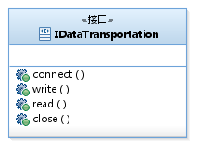

Data Transmission Interface
method | Parameter | Return Value | Function
connect | address: String  port:int | Object | Establish a data connection
write | xml:String | boolean | Send text to the output stream
read | 无 | byte[] | Receiving text from the input stream,
close | 无 | boolean | Close the connection

Encryption Interface
Function name | Parameter | Return Value | Explanation
encrypt | str:String | String | Encrypt incoming parameter and returns the result

Decryption Interface
Function name | Parameter | Return Value | Explanation
decrypt | str:String | String | Decrypt incoming parameter and returns the result

Public Class Design

Data processing class
Function name | Parameter | Return Value | Explanation
plusHead | length:int | byte[] | Join header (send text length)
readHead | buffer:byte[] | int | Read header (receiving text length)

Database Access Design

Database processing interface
Function name | Parameter | Return Value | Explanation
save | object:Object | void | Insert an Object object
findByProperty | propertyName:  String  value:Object | List<Object> | According to the table name, field name, value lookup data
findAll | None | List<Object> | Identify all data according to the table name
delete | object:Object | void | According to the table name, field name, the value of a one delete a record
update | object:Object | Object | Update an Object object

Interface design

Class diagram

Flow chart

Bluetooth Transportation implement IDataTransportation interface
1) Connect flow chart
- Write flow chart
- Read flow chart
- Close flow chart
Call close() function

FileDataTransportation implement IDataTransportation interface
- Connect flow chart
Open the local file
- Write flow chart
- Read flow chart
- Close()
Close the file stream

NetDataTransportation implement IDataTransportation interface
- Connect flow chart
- Write flow chart
- Read flow chart
- Close flow chart

MD5 implement IEncrypt interface

DES implement IEncrypt and IDecrypt interface

CheckDao implement IDatabaseDeal interface
- Save flow chart
- findAll flow chart

PersonInfoDao implement IDatabaseDeal interface
- Save flow chart
- findByProperty flow chart
- findAll flow chart
- update flow chart
- delete

Jar directory of Project Pack / Profile Design

Personal Edition
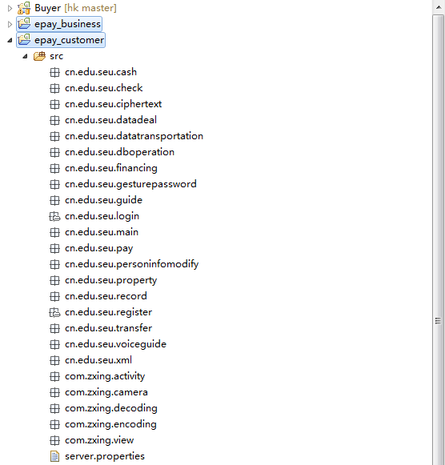
Jar pack: libs/zxing.jar
Profiles：project.properties
Variable 1: Server Address =honka.xicp.net
Variable 2:port=30145

Individual shop version
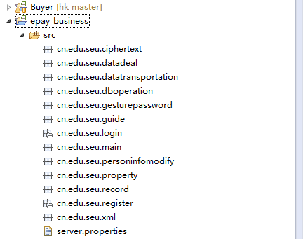
Profiles：project.properties
Variable 1: Server Address =honka.xicp.net
Variable 2: port=30145

Supermarket version
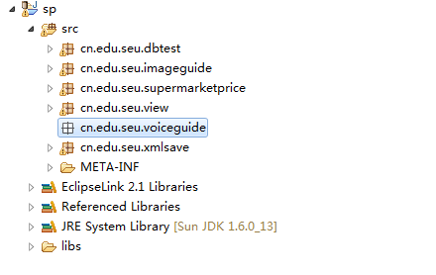
Profiles：project.properties
Variable 1: Server Address =honka.xicp.net
Variable 2: port=30145
server:
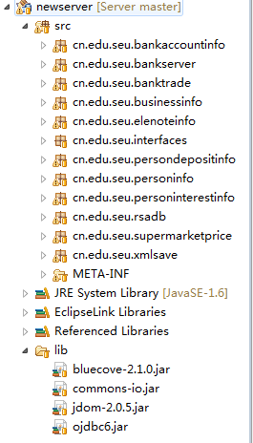

Web version

Detailed design of systems business

Registered Business

Class diagram + Timing Diagram
Class diagram：
Timing Diagram
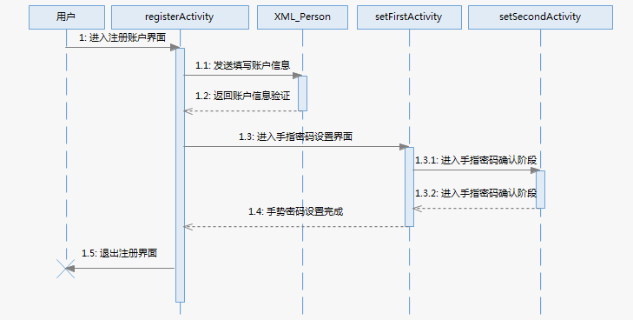

Class diagram description
1. PersonInfo:
Member variable | Type | Explanation
userName | String | User name
customerName | String | Real Name
cardNum | String | Bank card number
password | String | User password
bluetoothMac | String | Bluetooth address
privateKey | String | Private
identificationCardNum | String | ID number
phoneNum | String | Cell Phone Number
balance | String | Users Balance
IMEI | String | IMEI
publicKeyN | String | 公钥N
publicKeyD | String | 公钥D
member function | return | parameter
setUserName | void | String userName
getUserName | String | void
setCustomerName | void | String customerName
getCustomerName | String | void
setCardNum | void | String cardNum
getCardNum | String | void
setBluetoothMac | void | String bluetoothMac
getBluetoothMac | String | void
setDynamicPasswordNum | void | String dynamicPasswordNum
getDynamicPasswordNum | String | void
setIdentificationCardNum | void | String identificationCardNum
getIdentificationCardNum | String | void
setPhoneNum | void | String phoneNum
getPhoneNum | String | void
setPassword | void | String password
getPassword | String | void
setBalance | void | String balance
getBalance | String | void
setIMEI | void | String IMEI
getIMEI | String | void
setPublicKeyN | void | String publicKeyN
getPublicKeyN | String | void
setPublicKeyD | void | String publicKeyD
getPublicKeyD | String | void

2.XML_Person：
member variable | type | explanation
person | PersonInfo | 用户信息
member function | return | parameter
parsePersonXML | PersonInfo | InputStream is
productSentenceXML | String | String info
parseSentenceXML | String | InputStream is
producePersonXML | String | String event
produceRegisterXML | String | String event
produceUserNameXML | String | String event
produceLinkBankCardXML | String | String event
addPersonData | void | String userName, String customerName, String cardNum,String password,String bluetoothMac,  String dynamicPasswordNum, String identificationCardNum, String phoneNum, String balance
addPersonUserName | void | String userName
addPersonRegister | void | String userName, String password, String realName, String bluetoothMac
addPersonLinkBankCard | void | String userName, String cardNum, String phoneNum, String idCardNum

UI design

Referenced public module

Database
PERSON_INFO
Data name | type | explanation
userName | String | 用户名
customerName | String | 真实姓名
cardNum | String | 银行卡号码
password | String | 用户密码
bluetoothMac | String | 蓝牙地址
privateKey | String | 私钥
identificationCardNum | String | 身份证号码
phoneNum | String | 手机号码
balance | String | 用户余额
IMEI | String | 手机串号
publicKeyN | String | 公钥N
publicKeyD | String | 公钥D

Interface and Implementation
Interface
Implementation

Package and directory configuration
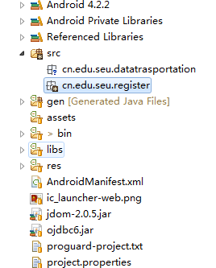

Sign Business

Class diagram、Timing diagram

Class diagram

Timing diagram for Normal login

Timing Diagram When files are deleted account login

Class diagram description
LocalIO
member variable | type | explanation
dirPath | String | 商品名
filename | String | 商品价格
ed | String | 商品条形码
member function | return | parameter
LocalIO |  | String dir  String file
writefile | void | LocalInfo l
readfile | LocalInfo
modifyGesturePwd | void | String newPwd
modifyPassword | void | String newGpwd
modifyBalance | void | String newBalance
modifyAvailableBalance | void | String newAvailableBalance

UI design

Referenced public module

4.2.4.1 Database
Local Account Information table local_person_info
Number | English name | Chinese name | Data Type | Primary key
1 | username | 用户名 | String | Yes
2 | password | 密码 | String | No
3 | customername | 真实姓名 | String | No
4 | gesturepwed | 手势密码 | String | No
5 | privatekey | 私钥e | String | No
6 | cardnum | 银行卡号 | String | No
7 | publickeyn | 公钥n | String | No
8 | balance | 余额 | String | No
9 | availablebalance | 可用余额 | String | No

Interface and implementation
interface：IDataTransportation
implementation：
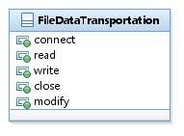

Parameter configuration
Account Information:sdcard/data/local.dat

Package and directory configuration

Transfer business

Class diagram, sequence diagram

Class diagram

Timing Diagram

Class diagram description
Trade
member variable | type | explanation
payerdevice | String | 付款人蓝牙地址
receiverdevice | String | 收款人蓝牙地址
payername | String | 付款人用户名
payerimei | String | 付款人手机IMEI
receivername | String | 收款人用户名
receiverimei | String | 收款人IMEI
tradetime | String | 交易时间
totalprice | String | 金额
cipher | String | 加密摘要
payercardnumber | String | 付款人银行卡号
receivercardnumber | String | 收款人银行卡号
member variable | return | parameter
Transfer |  | String payerdevice  String payername  String payerimei  String payercardnumber  String receiverdevice  String receivername  String receiverimei  String receivercardnumber  String tradetime  String totalprice  String cipher
Transfer
getPayerDevice | String
getReceiverDevice | String
getPayerName | String
getReceiverName | String
getTradeTime | String
getTotalPrice | String
getCipher | String
getPayCardNumber | String
getReceiverCardNumber | String
getPayerIMEI | String
getReceiverIMEI | String
setPayerDevice | void | String payerdevice
setReceiverDevice | Void | String receivedevice
setPayerName | void | String payername
setReceiverName | void | String receivername
setTradeTime | Void | String tradetime
setTotalPrice | void | String totalprice
setCipher | void | String cipher
setPayerCardNumber | Void | String payercardnumber
setReceiverCardNumber | void | String receivercardnumber
setPayerIMEI | void | String payeryimei
setReceiverIMEI | void | String receiverimei

UI design

Referenced public module

Database
- Check
number | English | Chinese name | data type | Primary key
1 | checkid | 编号 | Integer | Yes
1 | payername | 付款方用户名 | String | No
2 | payercardnum | 付款方银行卡号 | String | No
3 | payerimei | 付款方串号 | String | No
4 | totalprice | 交易金额 | Decimal | No
5 | tradetime | 转账时间 | String | No
6 | iscashed | 是否兑现 | String | No
6 | xml | xml | String | No
- Person_trade
number | English | Chinese name | data type | Primary key
1 | tradenum | 交易编号 | String | Yes
2 | payername | 付款方用户名 | String | No
3 | payermac | 付款方蓝牙地址 | String | No
4 | payerimei | 付款方串号 | String | No
5 | receivername | 收款方用户名 | String | No
6 | receivermac | 收款方蓝牙地址 | String | No
7 | receiverimei | 收款方串号 | String | No
8 | price | 交易金额 | Double | No
9 | tradetype | 交易类型 | String | No
10 | tradetime | 交易时间 | String | No

Interface and Implementation
Interface
Implementation

Package and directory configuration
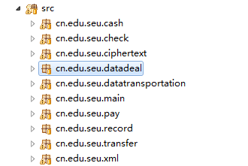

Payment Business

Class diagram, sequence diagram

Class diagram

Individual shop Payment
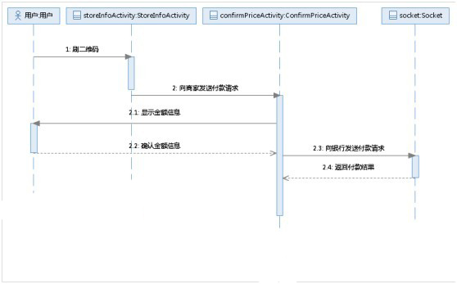

Supermarket Payment
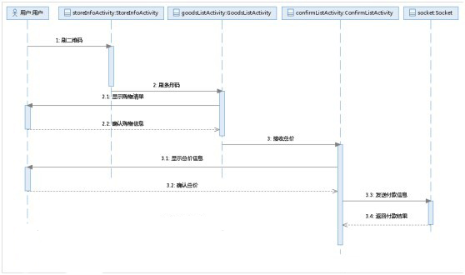

Class diagram description
- Goods
成员变量 | 类型 | 说明
name | String | 商品名
price | String | 商品价格
barcode | String | 商品条形码
quantity | String | 商品数量
成员方法 | 返回 | 参数
setBarcode | void | String barcode
getBarcode | String
getName | String
setName | void | String name
getPrice | String
setPrice | void | String price
getQuantity | String
setQuantity | void | String quantity
Goods
Goods |  | String barcode  String name  String price  String quantity
- Trade
member variable | type | explanation
payerdevice | String | Payer Bluetooth address
receiverdevice | String | Payee Bluetooth address
payername | String | Username payer
payerimei | String | Payer Mobile IMEI
receivername | String | Username payee
receiverimei | String | payee IMEI
tradetime | String | Trading Hours
totalprice | String | Money
cipher | String | Cryptographic digest
payercardnumber | String | Drawee bank card
receivercardnumber | String | Payee bank card
member function | type | parameter
Trade |  | String payerdevice  String payername  String payerimei  String payercardnumber  String receiverdevice  String receivername  String receiverimei  String receivercardnumber  String tradetime  String totalprice  String cipher
Trade
getPayerDevice | String
getReceiverDevice | String
getPayerName | String
getReceiverName | String
getTradeTime | String
getTotalPrice | String
getCipher | String
getPayCardNumber | String
getReceiverCardNumber | String
getPayerIMEI | String
getReceiverIMEI | String
setPayerDevice | void | String payerdevice
setReceiverDevice | Void | String receivedevice
setPayerName | void | String payername
setReceiverName | void | String receivername
setTradeTime | Void | String tradetime
setTotalPrice | void | String totalprice
setCipher | void | String cipher
setPayerCardNumber | Void | String payercardnumber
setReceiverCardNumber | void | String receivercardnumber
setPayerIMEI | void | String payeryimei
setReceiverIMEI | void | String receiverimei

UI design

Referenced public module

Database
- local_person_info (local account information table)
number | English name | Chinese name | data type | primary key
1 | username | 用户名 | String | Yes
2 | password | 密码 | String | No
3 | customername | 真实姓名 | String | No
4 | gesturepwed | 手势密码 | String | No
5 | privatekey | 私钥e | String | No
6 | cardnum | 银行卡号 | String | No
7 | publickeyn | 公钥n | String | No
8 | balance | 余额 | String | No
9 | availablebalance | 可用余额 | String | No
- manual_trade (Individual store transaction log table)
number | English name | Chinese name | data type | primary key
1 | tradenum | 交易编号 | Integer | Yes
2 | payername | 付款方用户名 | String | No
3 | payermac | 付款方蓝牙地址 | String | No
4 | payerimei | 付款方串号 | String | No
5 | receivername | 收款方用户名 | String | No
6 | receivermac | 收款方蓝牙地址 | String | No
7 | receiverimei | 收款方串号 | String | No
8 | price | 交易金额 | Double | No
9 | tradetime | 交易时间 | String | No
- Individual / individual store information table person_info
number | English name | Chinese name | data type | primary key
1 | username | 真实姓名 | String | Yes
2 | customername | 用户名 | String | No
3 | cardnum | 银行卡账号 | Integer | No
4 | password | 用户密码 | String | No
5 | bluetoothmac | 蓝牙地址 | String | No
6 | privatekey | 私钥e | String | No
7 | identificationcardnum | 身份证号 | String | No
8 | publickeyn | 公钥n | String | No
9 | publickeyd | 公钥d | String | No
10 | phonenum | 手机号码 | Integer | No
11 | balance | 用户余额 | Double | No
12 | imei | 手机串号 | String | No

Interface and Implementation
Interface
Implementation

Package and directory configuration
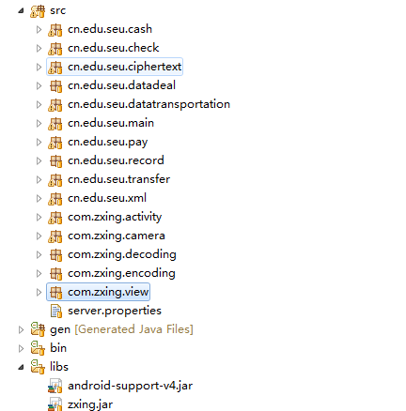

Deployment Design

System deployment diagram

Operating Environment
Server: Windows server 2008
Mobile client: above Android 2.2
PC client: Window7 with jdk

